**Dr Virendra Swaroop Insti. Of Compter Studies**



BACHELOR OF COMPUTER APPLICATION

**BATCH (2023-2026)**

Project-3

**TOPIC- Integrate Grafana with Linux Server for high cpu utilization and create a graph in Grafana**

**SUBMITTED BY:- SUBMITTED TO:-**

**Shubh gupta ABHINAV SIR**

**BCA SEMESTER - 4**

Project:-3

**Integrate Grafana with Linux Server for high cpu utilization and create a graph in Grafana.**

**Task1-** Sign in to AWS Management Console

1. Click on the Open Console button, and you will get redirected to AWS Console in a new browser tab.

* On the AWS sign-in page, Leave the Account ID as default. Never edit/remove the 12-digit Account ID present in the AWS Console. otherwise, you cannot proceed with the lab.
* Now copy your User Name and Password in the Lab Console to the IAM Username and Password in AWS Console and click on the Sign in button.

2. Once Signed in to the AWS Management Console, Make the default AWS Region as Mumbai(ap-south-1).

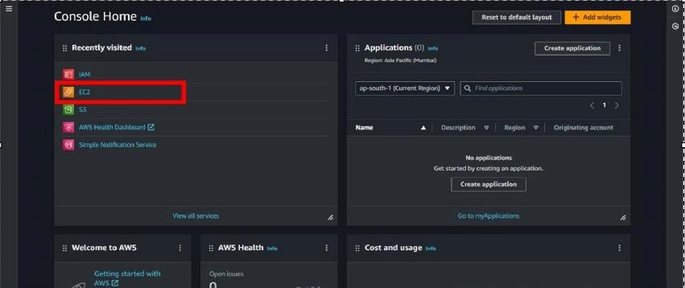

Create an EC2 Instance(Amazon Linux):

* For creating an EC2 instance follow the following steps as shown in snapshots.

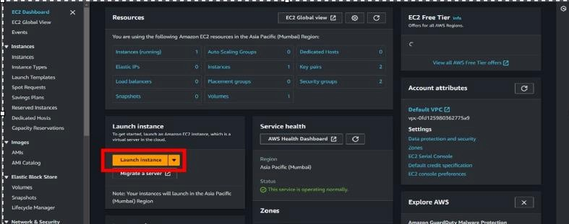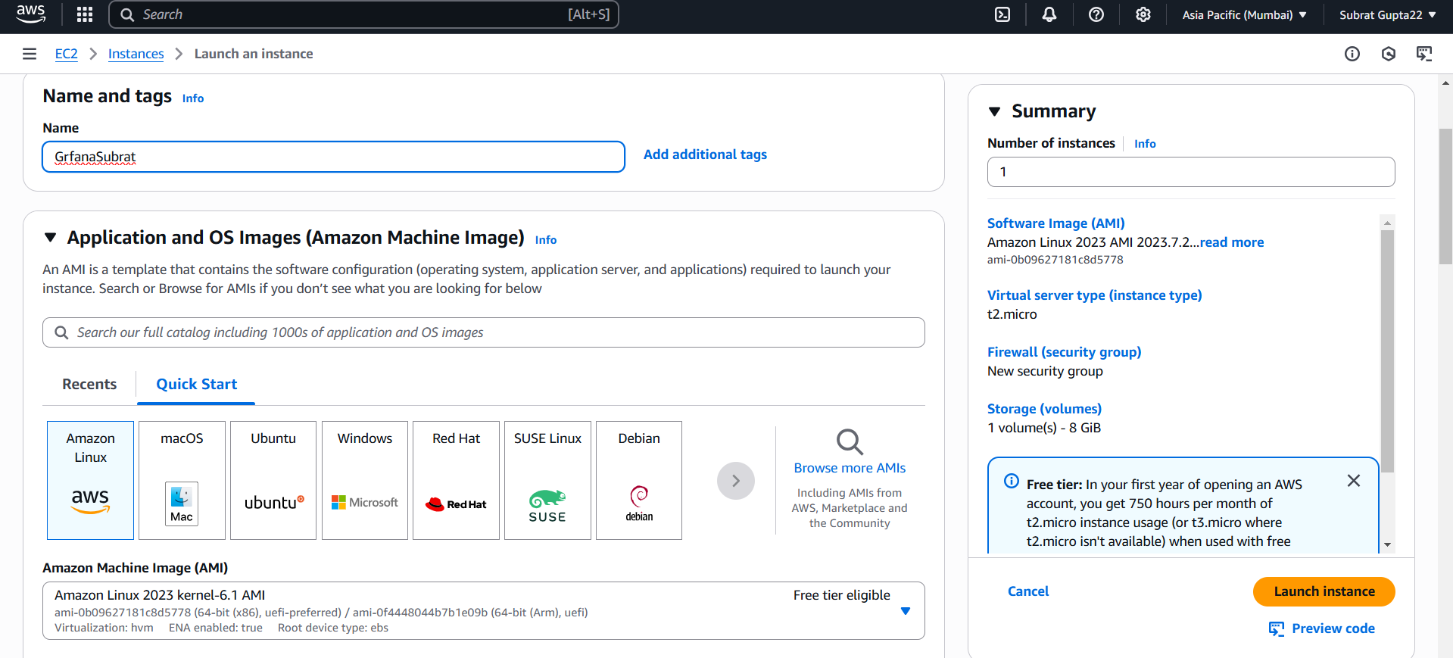

* Provide the EC2 name of your choise and select”**Amazon Linux”**as an OS Image.

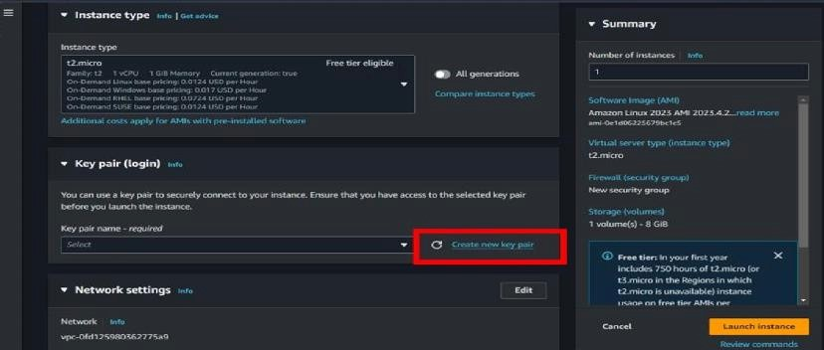

* Create a new key pair. (make a .ppk For putty)

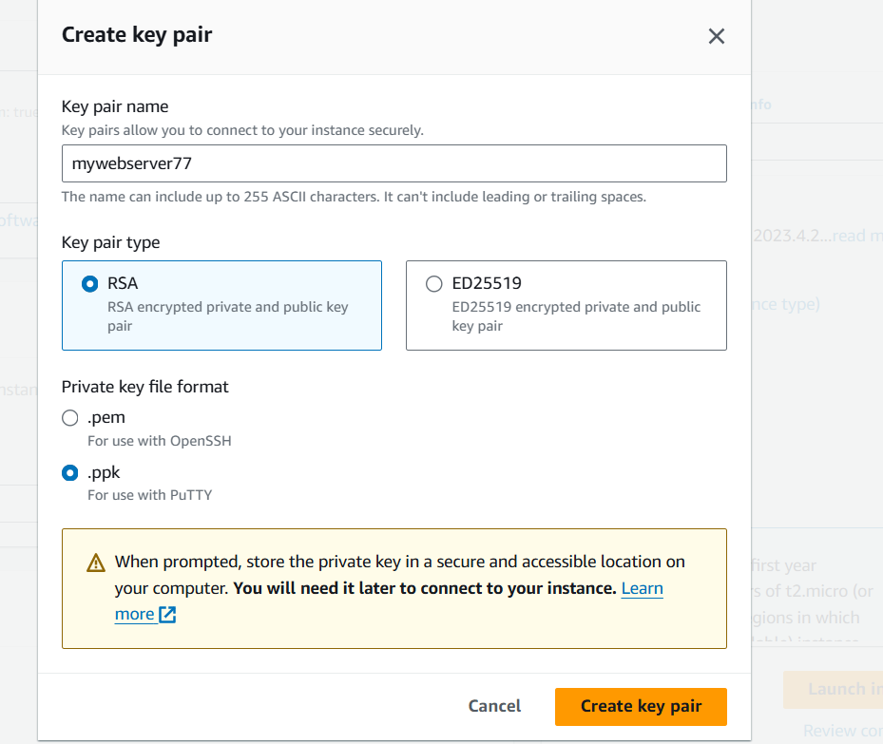

* Scroll down and click on “**LAUNCH INSTANCE** “.

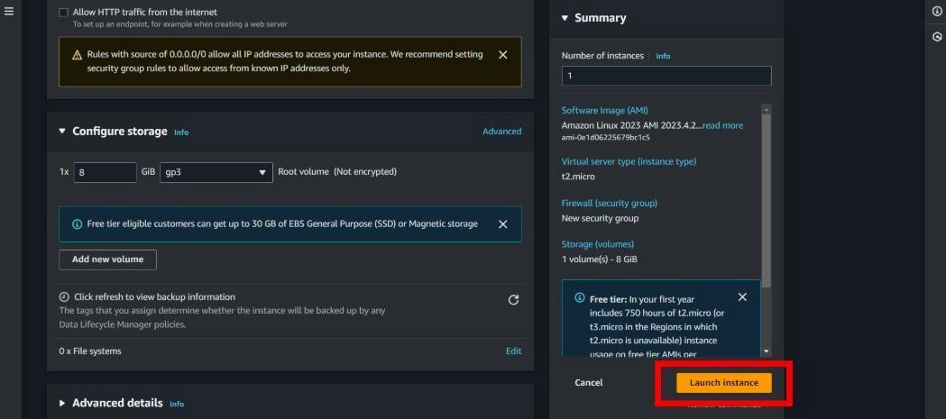

* Then open your instance.

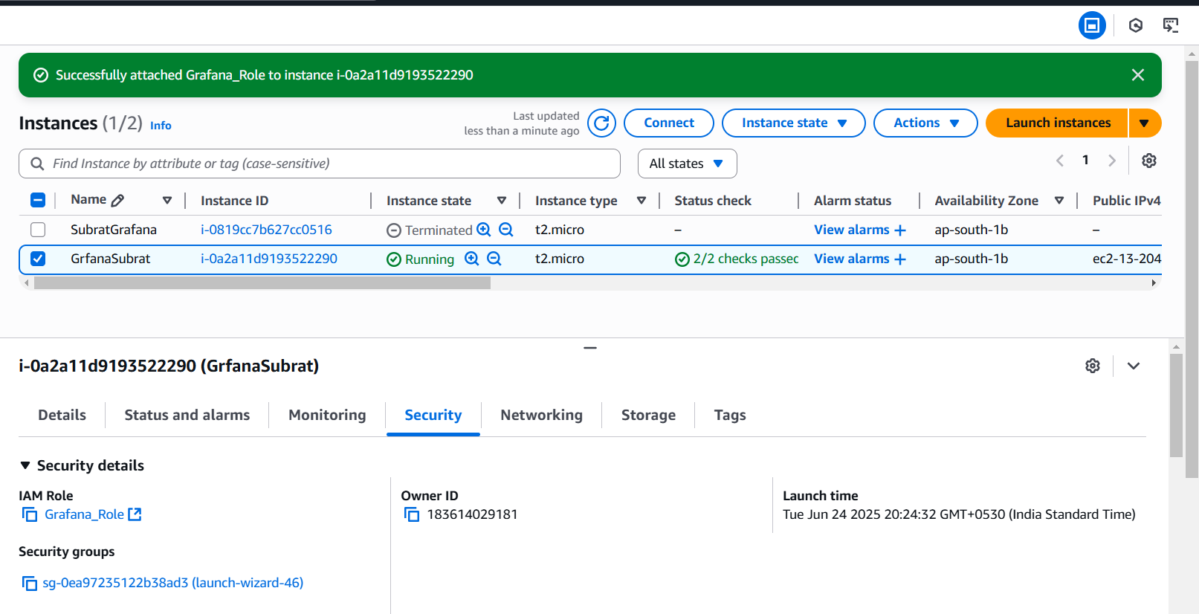

**Task 2-**create a I am role and attach it to instance

Step1-search IAM on search bar and select

Step2- go to roles given in left panel

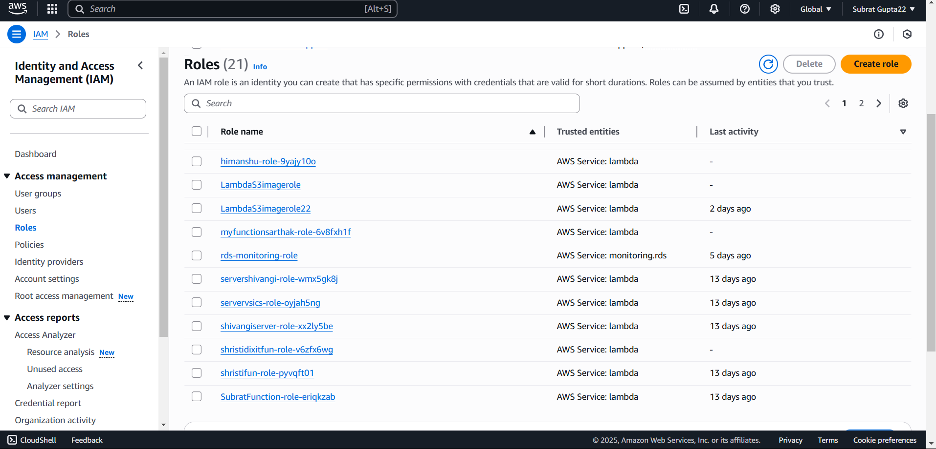

Step2- go to roles given in left panel

Step3-create role

* select aws service
* select EC2 in use case then click (next)

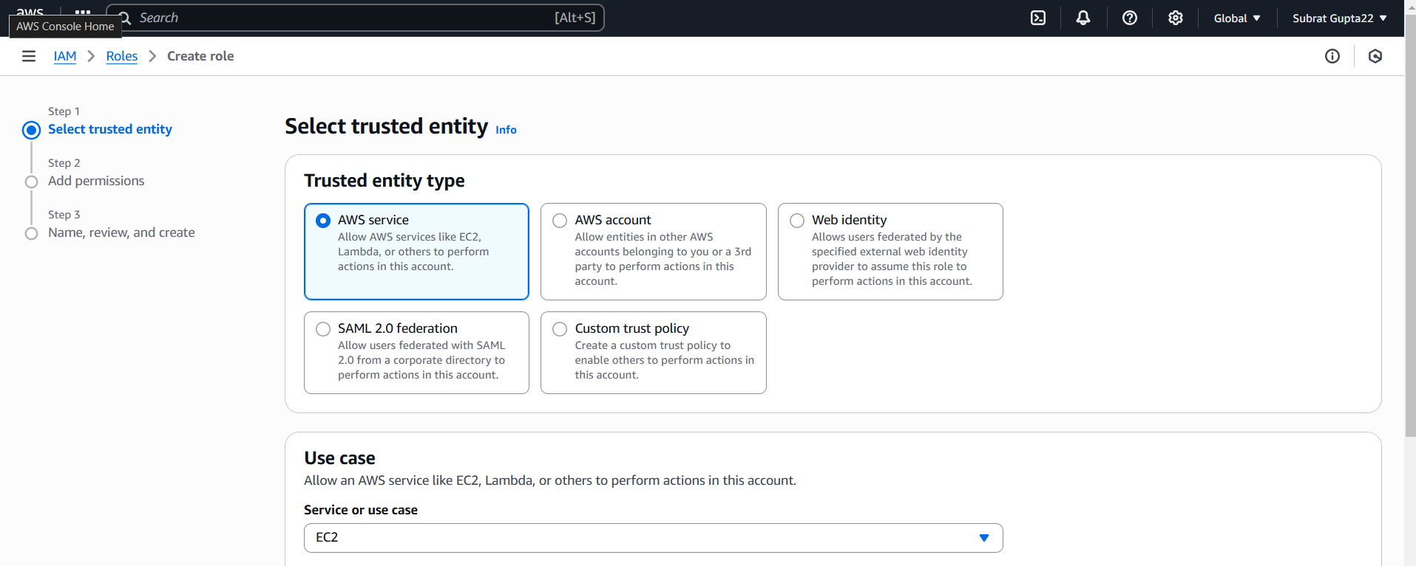

* now select full administration access and full access to cloud watch.

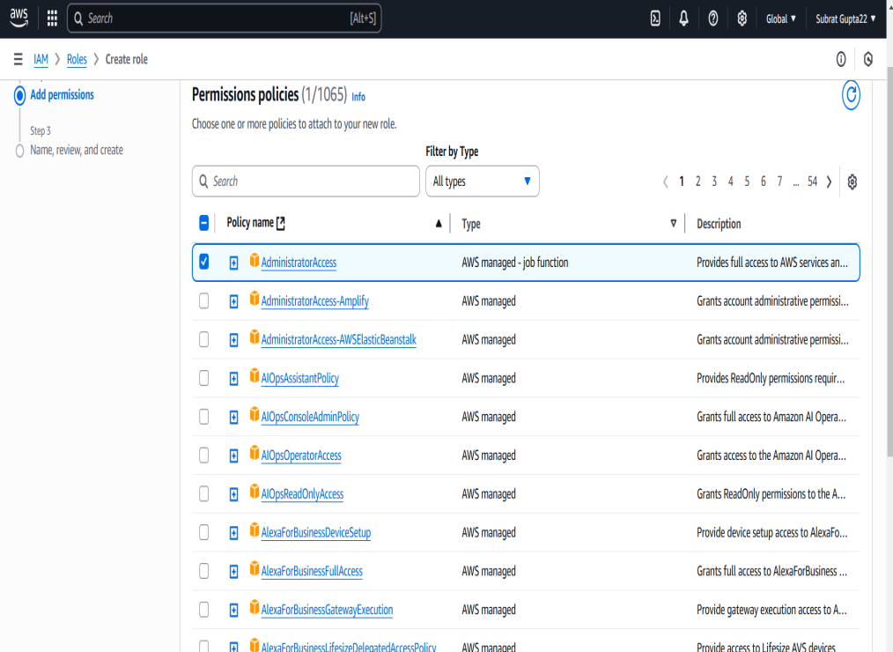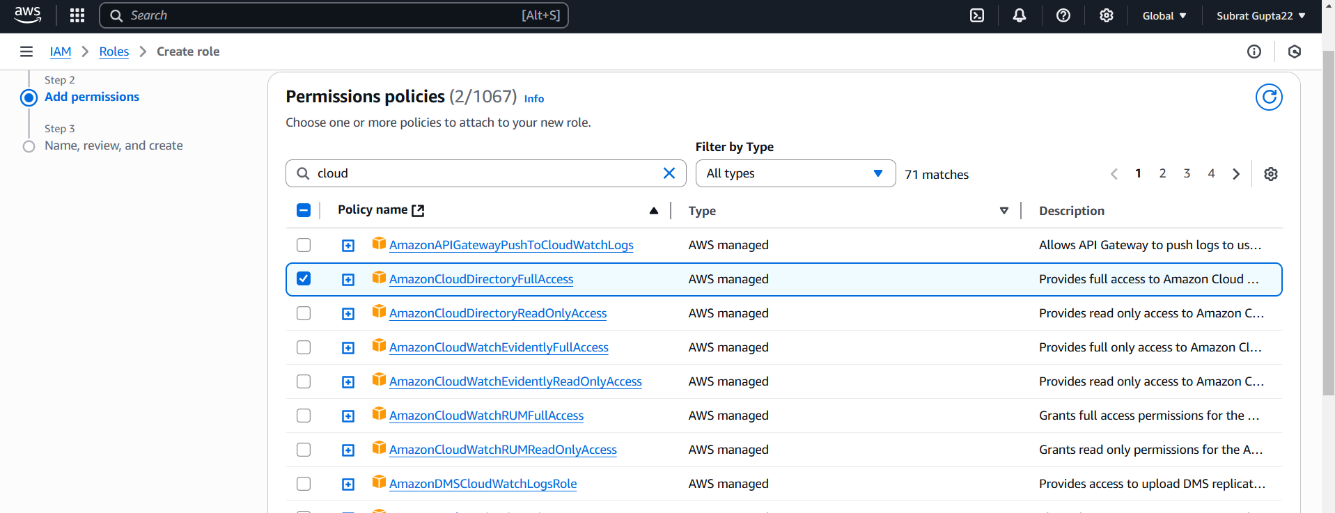

* then select (next)
* give the role name-Grafana_role.
* go back to EC2 and Select your instance and goto actions.

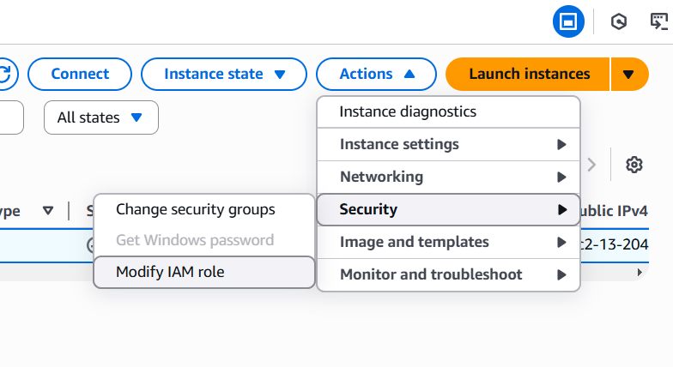

* select security -à modify IAM role
* and select (Grafana_role )
* Click (update IAM role)

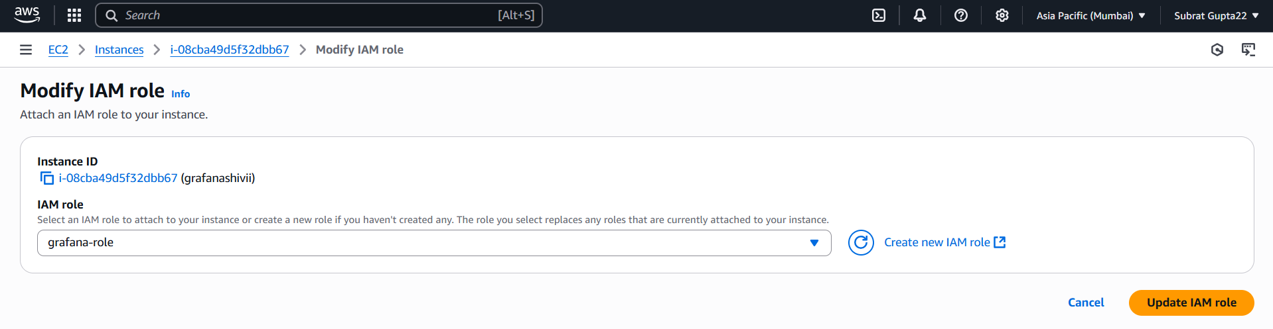

**Task3-** give access to port 3000 because grafana runs under port 3000

* In instanc select security
* Then scroll down and open the security group link

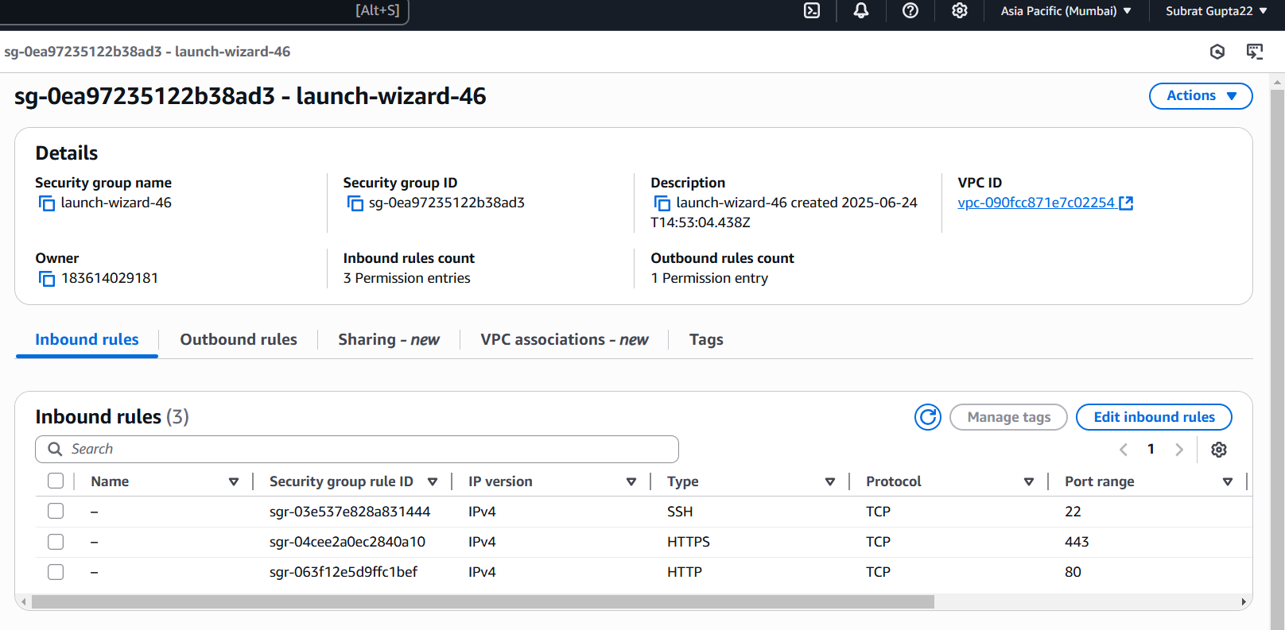

* Go to( Edit Inbound rules)
* Then select (add rule) in down left corner .
* Select type-Custom TCP
* Port range – 3000
* Source- Anywhere IPv4
* Click save rules

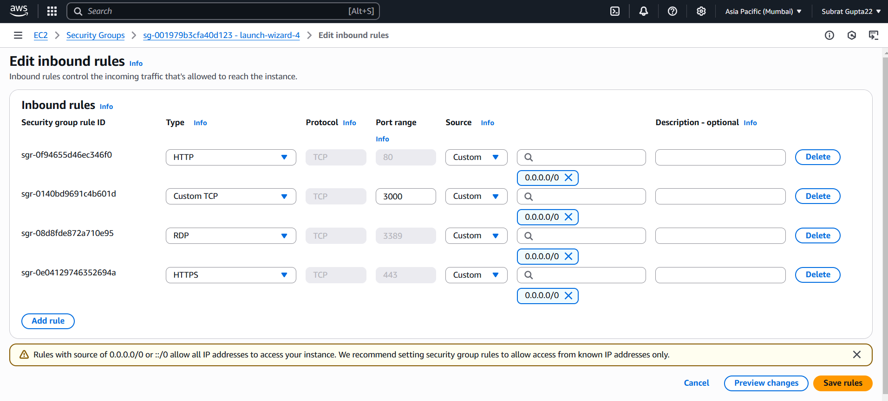

**Task4-** Start the Instance

* Go to putty àpaste IPv4 addresss
* Then +SSHà+auth(open)
* Browse and attach .ppk key(open)
* Login as- ec2-user
* Your instance has started

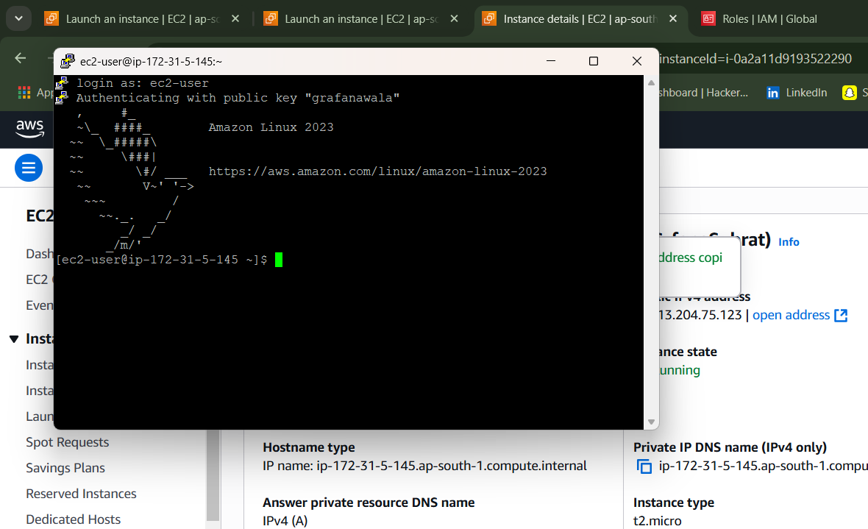

* After connecting the instance follow the given command .

* *sudo yum get update*
* *sudo -i*
* sudo yum install -y <https://dl.grafana.com/enterprise/release/grafana-enterprise-12.0.2-1.x86_64.rpm>
* wait to install
* *systemctl start grafana-server.service*
* *systemctl enable grafana-server.service*
* *systemctl status grafana-server.service*
* press q to come out
* *netstat –tunpl* |grep grafana

Then paste your copied ip address and type “**:3000”** after ip address and search it .

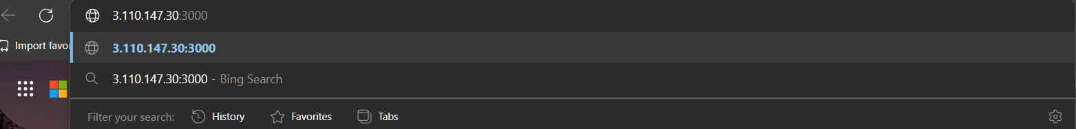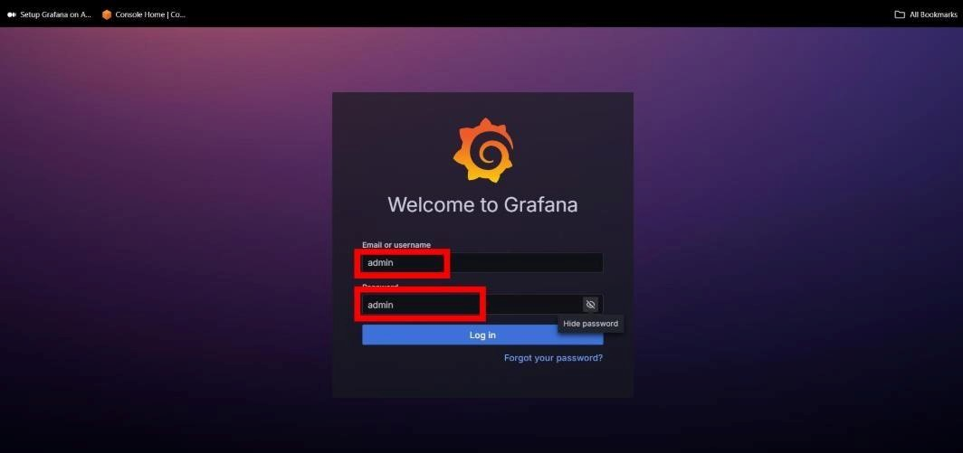

* Then login in Grafana by the help of credientials shown in above snapshot.

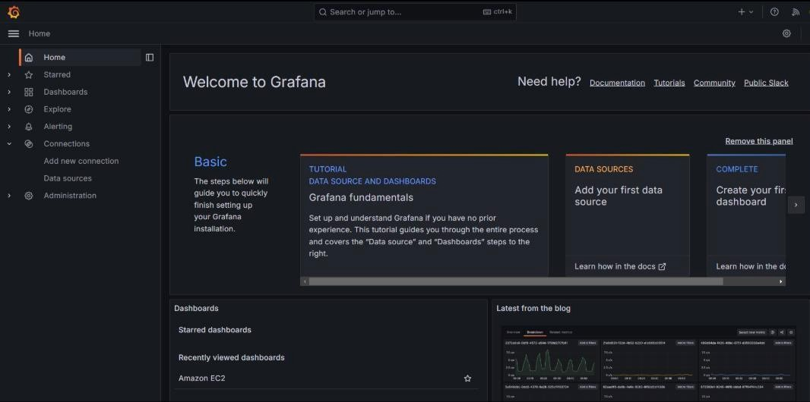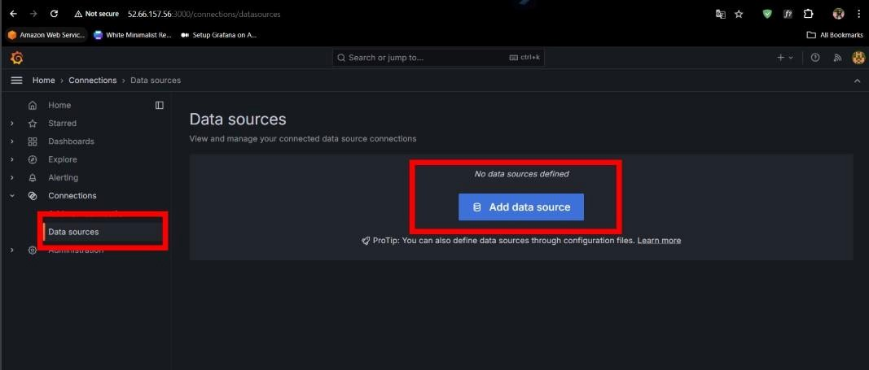

* Then go to **Dashboard** and click on **Adddata source** .

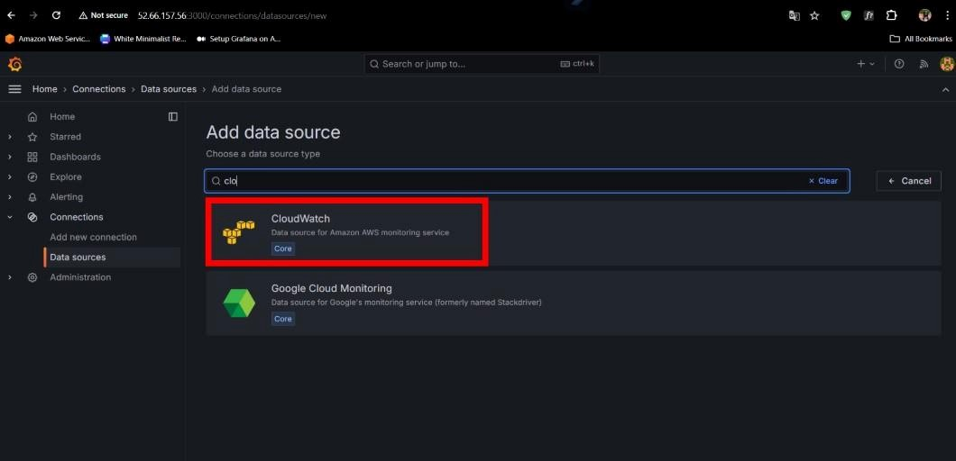

* Now , select “**Cloudwatch**” as an data source .
* Select Authentication Provider Accesses& secret key

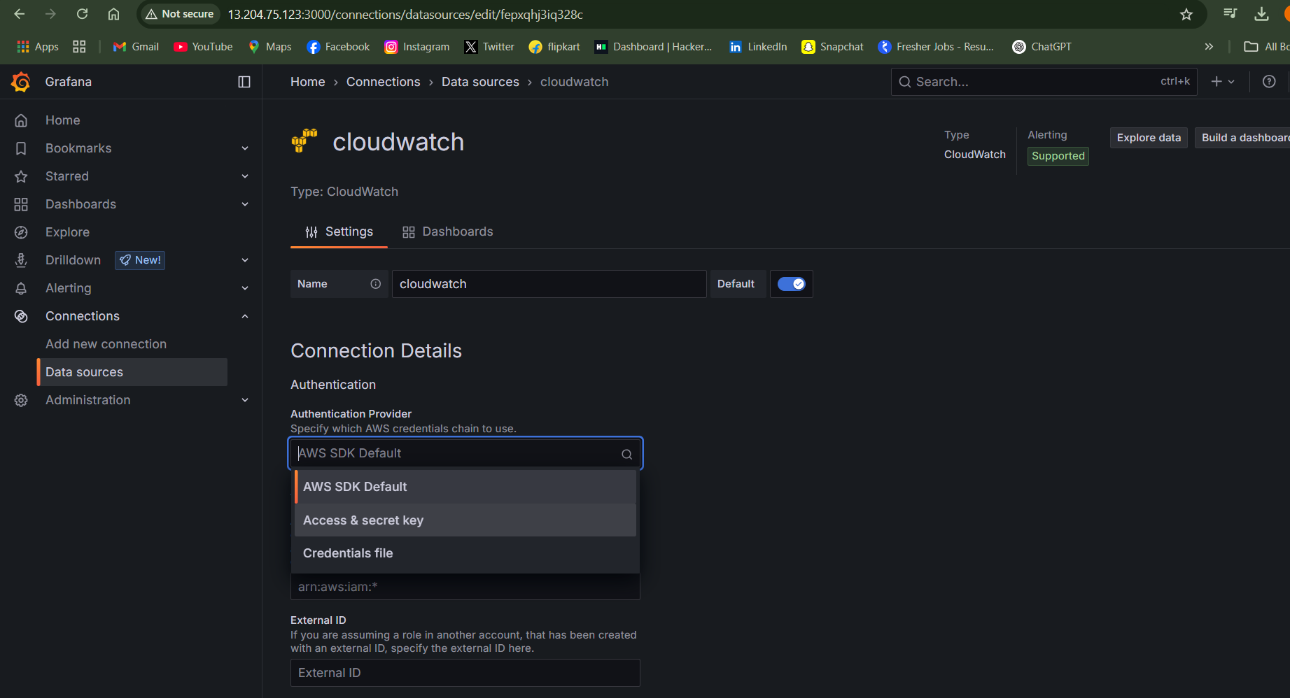

* Now go back to aws IAM previously opened
* Open user
* Select IAM user

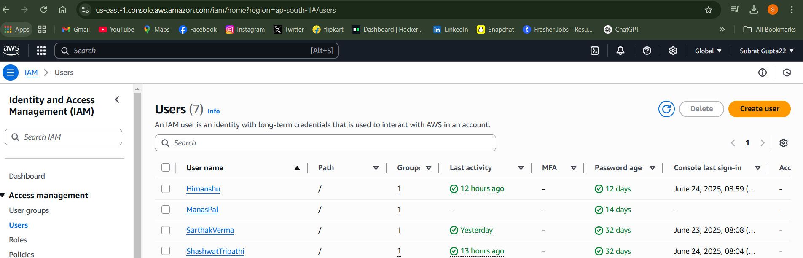

* Go to Security credentials scroll down to access key
* Create access key

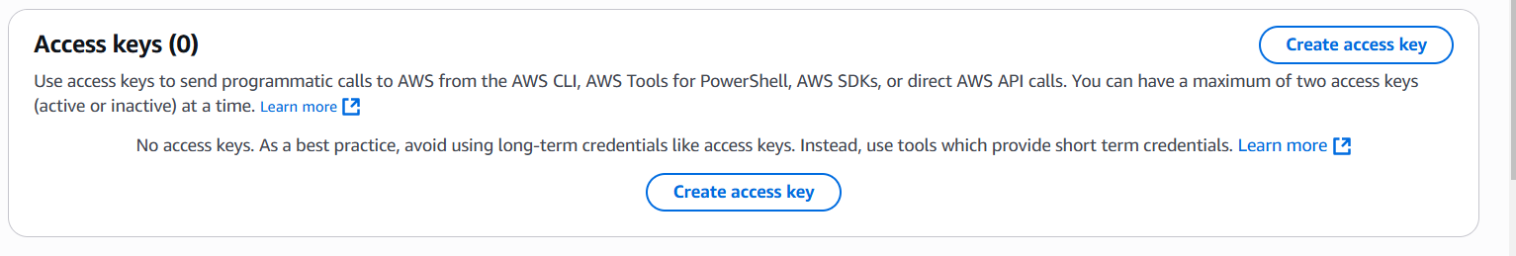

* Then Select CLI then check the confirmation box
* press next

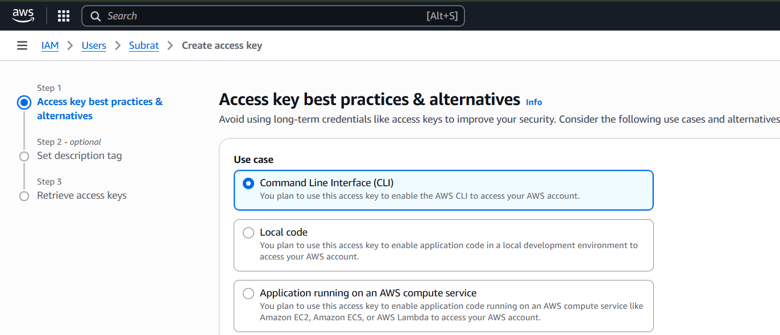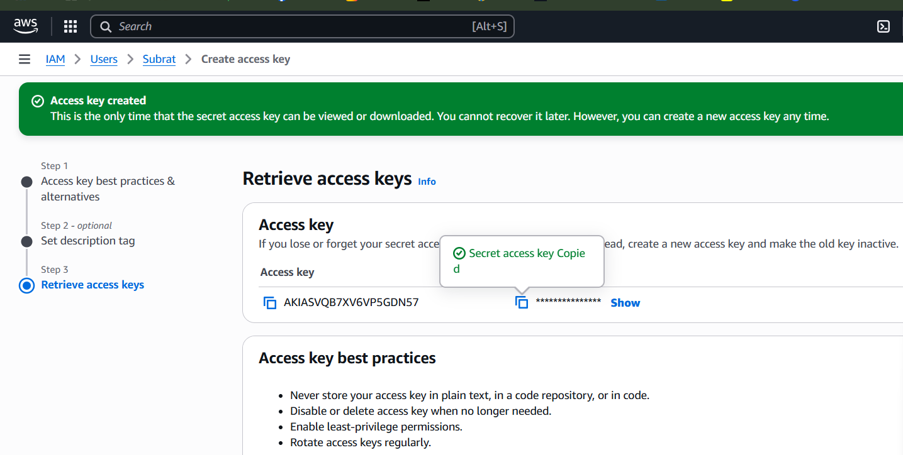

* Now copy access key and secret access key in grafana

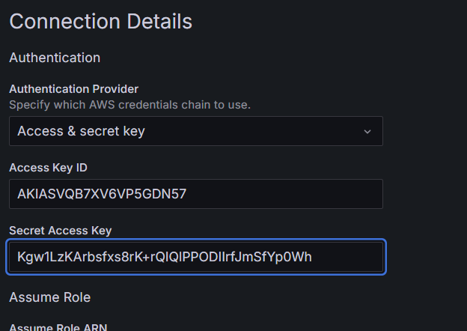

* Select your region (ap-south -1)
* then select SAVE & TEST
* dash board is created

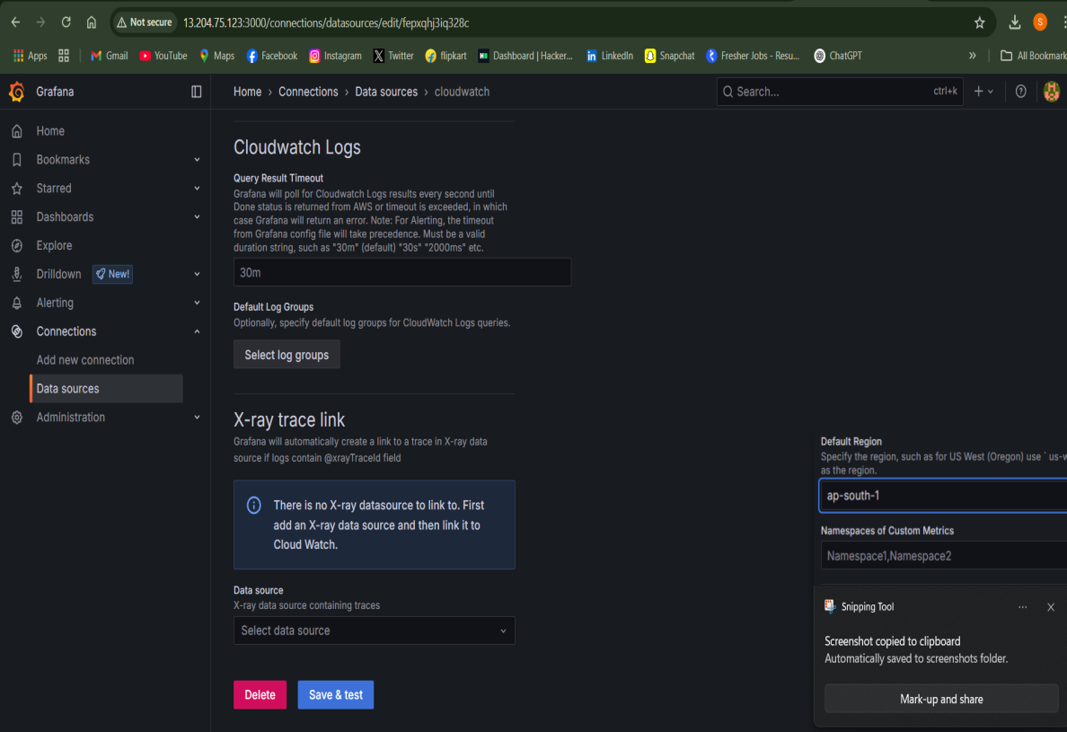

* now select data sources in left panel
* you can see cloud watch
* go back to home in left panel
* go to create your dash board

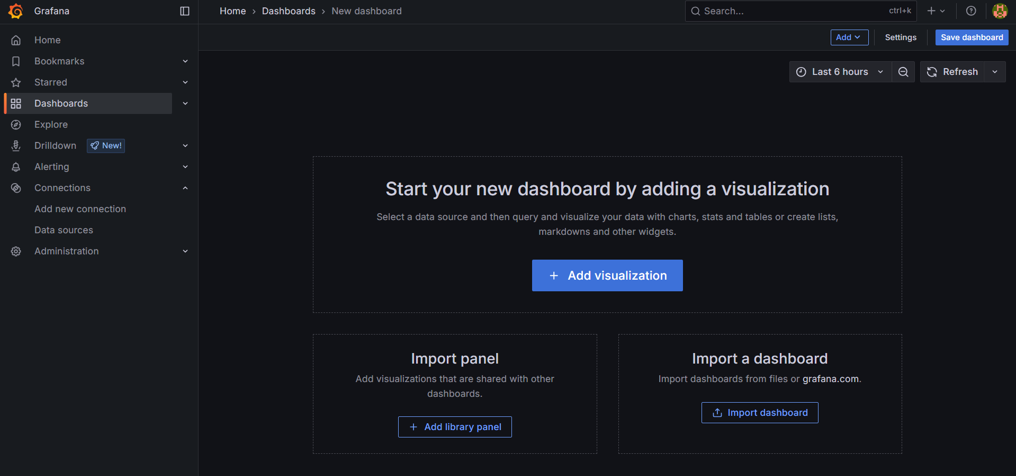

* import a dashboard

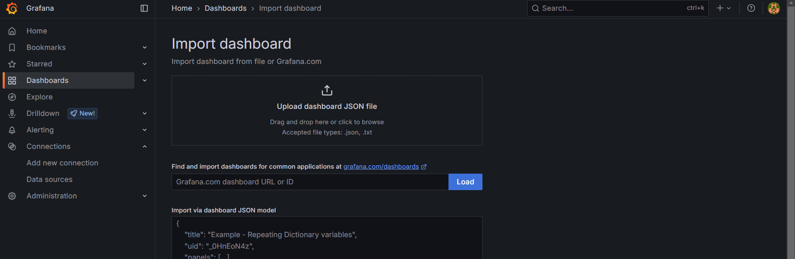

* type 11265
* click load

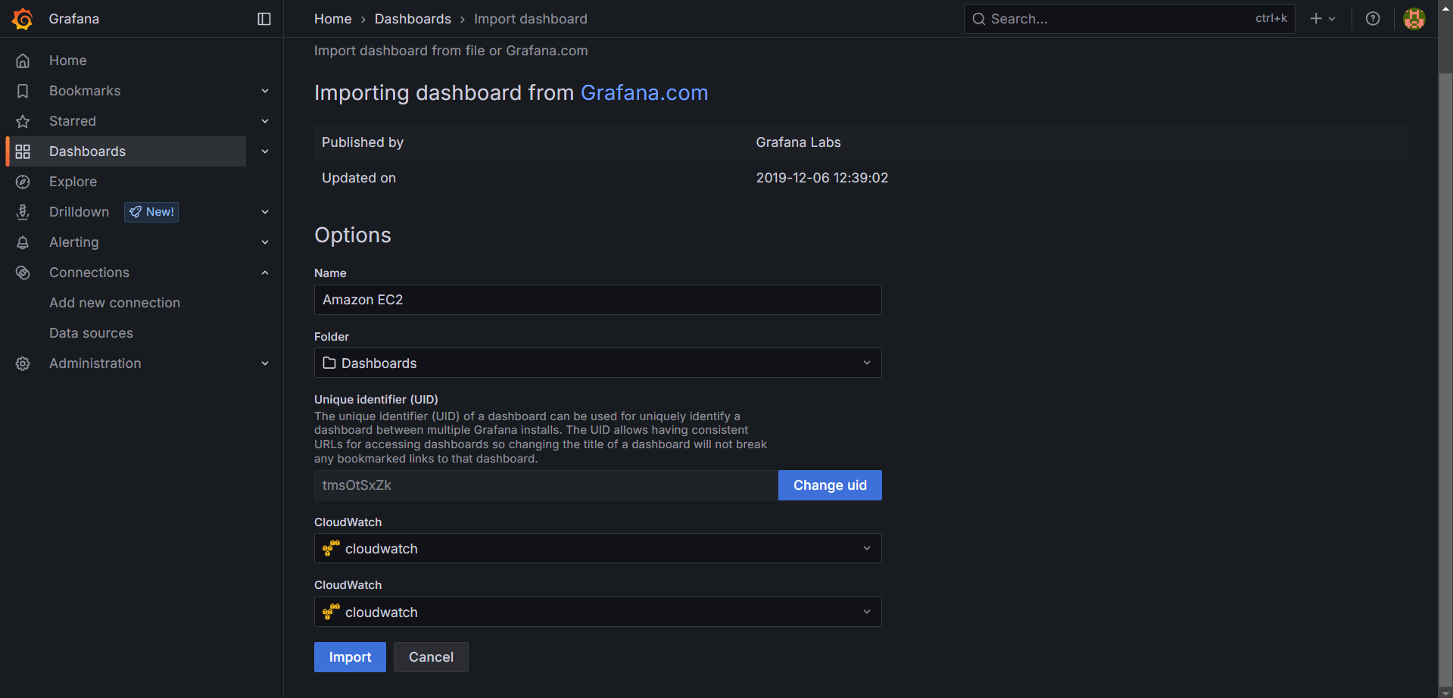

* now cloud watch in both cloud watch.
* Select import
* Grafana is created

